**FILES AND DIRECTORIES**

**LAB # 08**



**Fall 2023**

**CSE-302L Systems Programming Lab**

Submitted by: **Ali Asghar**

Registration No**. : 21pwcse2059**

Class Section: **C**

“On my honor, as student of University of Engineering and Technology, I have neither given nor received unauthorized assistance on this academic work.”

Submitted to:

**Engr. Abdullah Hamid**

DATED: 28 \01 \2024

**Department of Computer Systems Engineering**

**University of Engineering and Technology, Peshawar**

**OBJECTIVES:**

* To learn about UNIX Files and Directories.
* To learn about Directory opening and reading

**Tasks:**

**Task 01:**

Implement ls command.

Code :

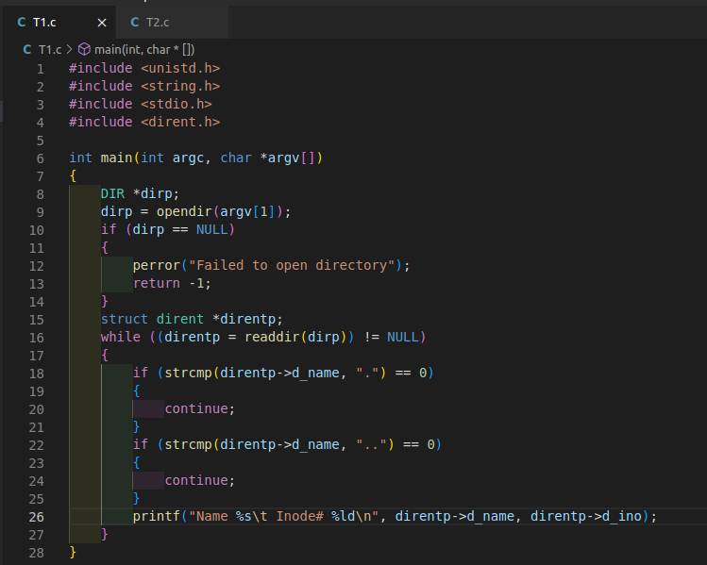

**Output:**

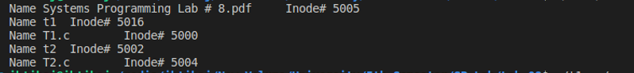

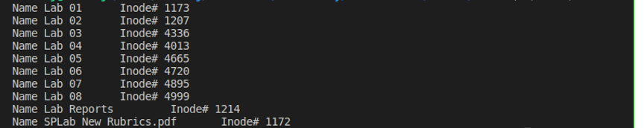

**Task 02:**

Implement ls -l command.

Code :

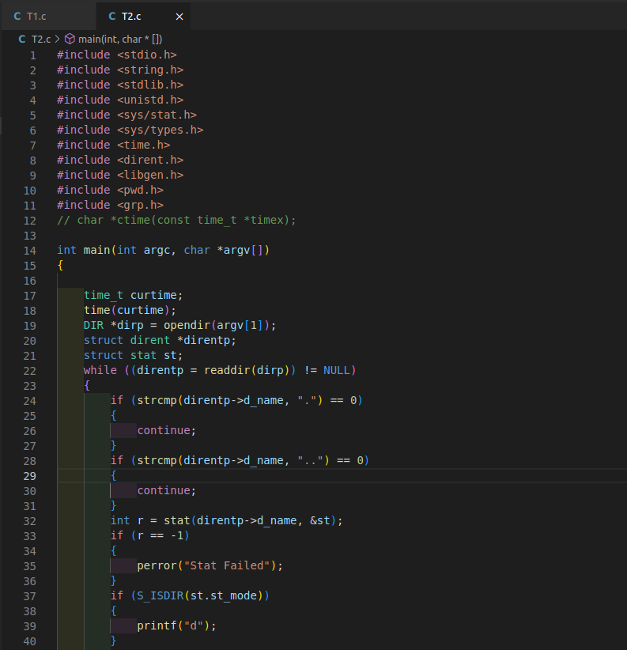

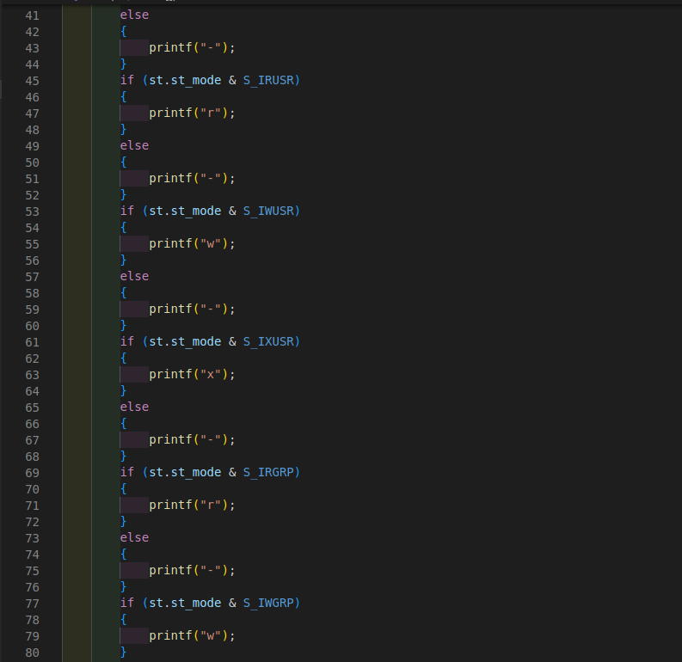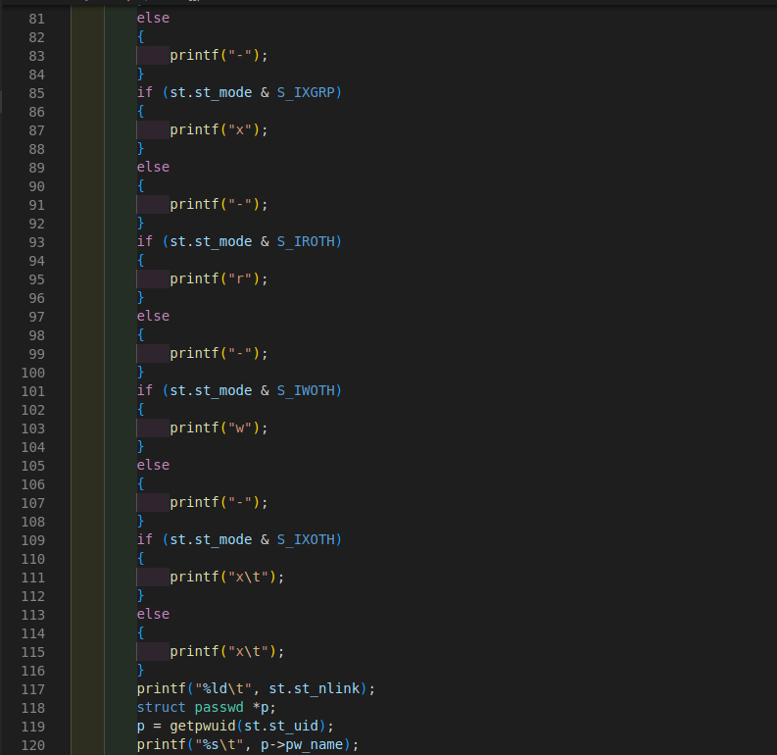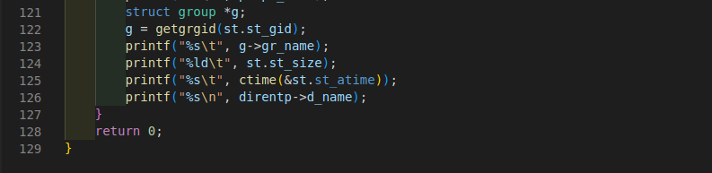

**Output:**

